**MAIN HOME:**

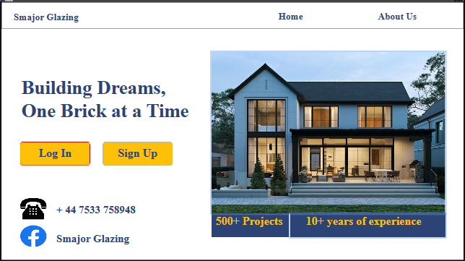

**ABOUT US:**

**SIGN UP:**

**LOGIN:**

**OWNER PROFILE:**

**OWNER DASHBOARD:**

**OWNER MANAGE PROJECTS:**

**OWNER INVENTORY:**

**OWNER PROJECT HISTORY:**

**OWNER PAYMENT MANAGEMENT:**

**OWNER ORDER REQUESTS:**

**OWNER FEEDBACKS:**

**CLIENT PROFILE:**

**CLIENT HOME:**

**CLIENT ORDER REQUEST:**

**CLIENT FEEDBACK:**

**CLIENT WINDOWS:**

**CLIENT DOORS:**

**CLIENT PROJECT HISTORY:**

**EMPLOYEE PROFILE:**

**EMPLOYEE TASKS:**

**LOGICAL SCHEMA:**

**ENTITY RELATIONSHIP DIAGRAM:**

